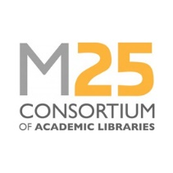
Staff Development Award: Attendance at the M25 Annual Conference
Application form
February 2021
Completed forms should be returned to the Executive Manager (rachel.telfer@london.ac.uk) by the closing date stated on the website.

Name of applicant |  | Date:
Current job title
Current employer
Application supported by senior manager in your service | Name:
 | Signature:
 | Date:
Guidance for applicants:
- Applicants must be a library staff member of a Consortium member institution.
- Applications will be evaluated by a small panel from the M25 Steering Group.
- Applicants must demonstrate how the specific award will benefit their career, and/or will enable them to bring something positive back for their team or library service.

Applicant’s supporting statement (maximum 500 words):

