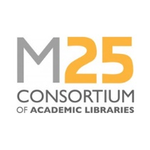
Staff Development Award: Conference bursary application form
September 2020
Completed forms should be returned to the Executive Manager (rachel.telfer@london.ac.uk) by the closing date stated on the website.

Name of applicant |  | Date:
Current job title
Current employer
Application supported by senior manager in your service | Name:
 | Signature:
 | Date:
Guidance for applicants:
- Applicants must be a library staff member of a Consortium member institution.
- Applications will be evaluated by a small panel from the M25 Steering Group.
- Applicants must demonstrate how the specific award will benefit their career, and/or will enable them to bring something positive back for their team or library service.
- Applicants are advised to provide a breakdown of the total costs to be incurred, specifying particular items for which application is being made to the M25 Consortium. Please include details of any additional funds you have secured towards attending the conference.
Applicant’s supporting statement (maximum 500 words):

