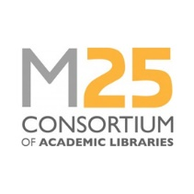

M25 Consortium of Academic Libraries Staff Development Award application form
Please complete one application form for each award you wish to apply for. Forms should be returned to the Executive Manager (m25libadmin@london.ac.uk) by the closing date stated on the website.

Name of applicant |  |  |  | Date:
Current job title
Current employer
Application Supported by Senior Manager in Your Service | Name:
 | Signature:
 | Date:
Award applied for | Award 1: bursary | Award 2:  2 days of CPD25 training | Award 3:  1 day of CPD25 training | Award 4: place at M25 Conference
Applicant’s supporting statement (maximum 500 words):

Delete as necessary. Complete a separate form for each application, if applying for more than one award.

